Task No & Title: | BSBCMN211A Participate in workplace safety procedures
Title: | Anthropometrics and ergonomics Explained worksheet
Suitable for Classes: | Certificate II Business Cert II in ICT
Area: | Technology & Enterprise
Teacher: | Mr Peter Faulks
Timeline | 1 Lesson
Date Due: | Today

Task Brief:
Files Required | Camera

Items highlighted in yellow are tasks for you to complete
Items in Blue are help tips

ERG111 Anthropometrics and ergonomics

Anthropometrics is the comparative study of human body measurements and properties. Ergonomics is the science of making the work environment safer and more comfortable for workers using design and anthropometric data.

Ergonomics
The prolonged use of computing equipment, especially the keyboard and mouse can cause serious physical injuries. Some of the injuries include damage to vision repetitive strain or stress and overuse syndrome. These injuries can be minimised by the taking of simple precautions and in particular taking care of our posture.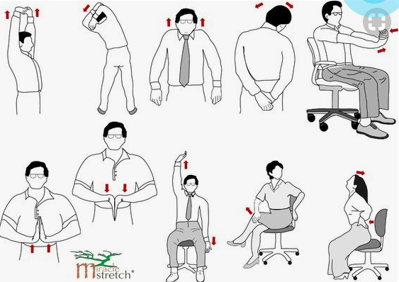
With more and more occupations requiring the use of information technology equipment in the daily operations, ergonomics and the design of equipment and furniture is increasing in importance. Hence, the office (and even the home) environment is a specialised area that needs to be looked at separately in terms of the design of office furniture and equipment.

Experiment
1. If you have access to the Internet, trying using a search engine such as Goggle or AltaVista to find ergonomically designed furniture and equipment.
http://www.ergonomics.com.au/how-to-sit-at-a-computer/
Anthropometrics  Ergonomics has been influenced by anthropometrics. Research of the human body has established that there is no average human. Everybody is different and office furniture and equipment needs to be designed with this in mind. For example chairs and desks need to be able to cater for all sizes therefore seats must be adjustable by height and tilt depending on the tasks being carried out. | 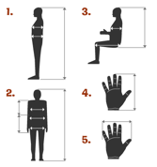

Experiment
Use the diagrams as a guide to measure all of your family members. Compare their measurements. Record your results in a table and answer the following questions:

1. How do you adjust the height of your equipment to meet differences in height of your family members?

https://greatist.com/grow/ergonomic-tips-sitting
ANSWER:

- How might the hand span measurements impact on the choice of mouse used with the computer?

http://www.goldtouch.com/mouse-sizing-guide/

http://umich.edu/~desci501/2011/Team10/APD11_T10_FINALREPORT.pdf
Answer:

Look at ergonomic mouse option
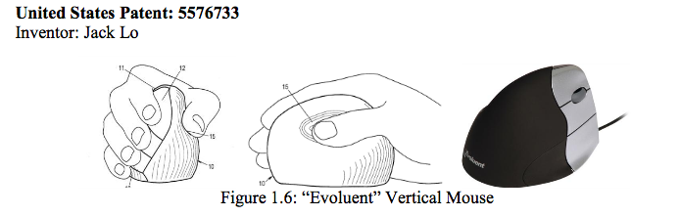

To do
Take a photograph of someone in a good ergonomic position using a computer and then a photograph in a poor position add these to your portfolio with explanation

STEP 1: Your Chair
- Push your hips as far back as they can go in the chair.
- Adjust the seat height so your feet are flat on the floor and your knees equal to, or slightly lower than, your hips.
- Adjust the back of the chair to a 100°-110° reclined angle. ...
- Adjust the armrests (if fitted) so that your shoulders are relaxed

Ergonomics checklist
Have someone you know observe you at your workstation and complete the checklist for you. Use the Internet if need be for help with identifying any possible solutions.
Add comments where necessary on how your workstation could be modified to make it safer.
Name: Date:
Observed by: Signature

Computer set-up | Yes | No | Possible Solutions
Does the work area provide enough space to work in comfort?
Does the workspace have good ventilation?
Does the chair have a five star base and wheels?
Can the chair be adjusted?
Are feet flat on the floor or on a footrest?
Is the lower leg at 90 degree angle to the thigh?
Is there a 90 degree angle between the upper arm and the lower arm?
Is the angle between the trunk and the thigh 90 – 130 degrees?
Is there an inward curve of the spine in the lumbar region?
Is the computer on flat stable surface?
Is the keyboard centred in front of the user?
Is the keyboard tilt adjusted for user comfort?
Can the user reach their arms out and just touch the monitor?
Is the top of the screen at or slightly below eye level?
Is the screen brightness and contrast correct for the user?
Is the screen clean?
Is there a lot of glare from your screen?

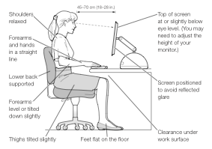Save your work as (your initials)_ERG111anthropometrics into your Folder or Portfolio.

